Handwriting Analysis Lab
Essential Question
How do forensic analysts observe and pieces of handwriting found at a crime scene? How can handwriting lead to a suspect and eventual charges against him/her?
Vocabulary
- Size: height and width of the letter; measure using a ruler
- Slope: letters are either straight, slanted to the right, slanted to the left, or a combination
- Special characteristics: dot on i’s, crosses on t’s, loops, twirls, distinguishing letters
Background & Purpose
Handwritten notes are potential pieces of evidence that could be purposefully (or accidentally) left at a crime scene. Forensic scientists are trained in analyzing the handwriting so that it can be matched to a specific suspect. Handwriting contains individual characteristics that make it unique, but it does require large amounts of skill and patience to analyze it properly. Some characteristics to look for include the following:
- Size of the writing
- Straight writing, sloped, or a combination
- Spacing between words
- Print, cursive, or both
- Unusual features such as i's dotted with hearts or circles, loops on L’s, curved y’s, etc.
Materials
- Handwriting Analysis Lab
- Pen or pencil
- Magnifying glass
Procedure
- Observe the handwriting between the five suspects using a magnifying glass.
- Compare your observations to the handwriting found at the crime scene.
- Record your observations in the Data Collection table.

Culprit’s Handwriting
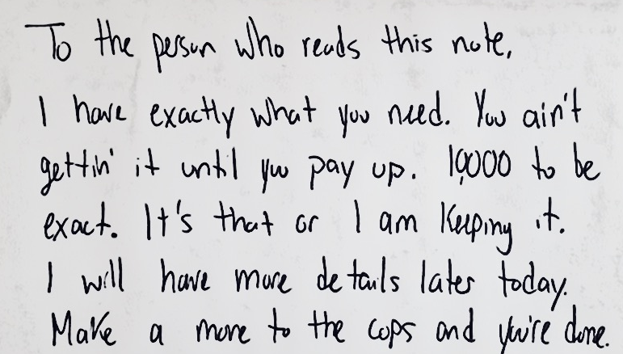
Data Collection

Suspect 2
Suspect 1
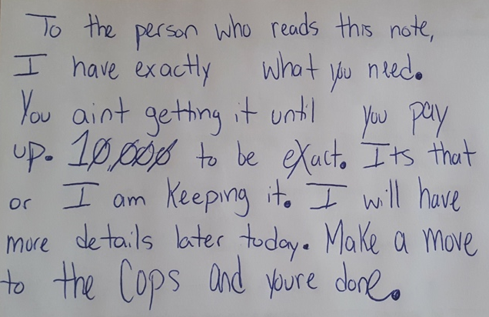
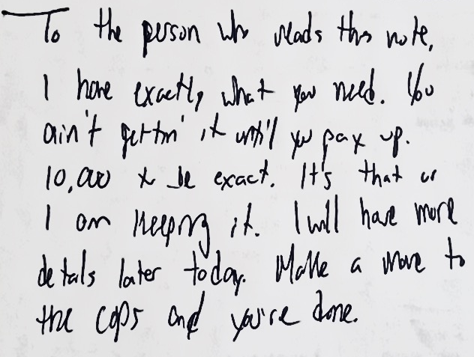

Suspect 4
Suspect 3
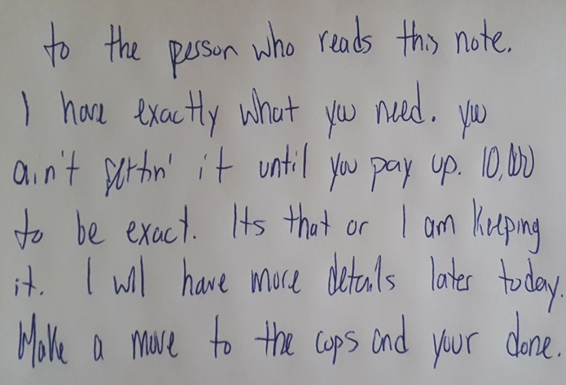
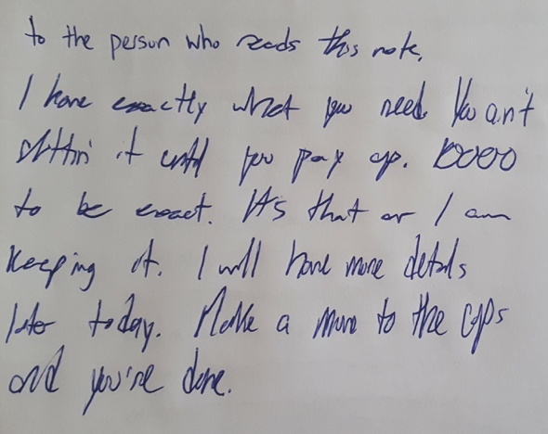

Suspect 5
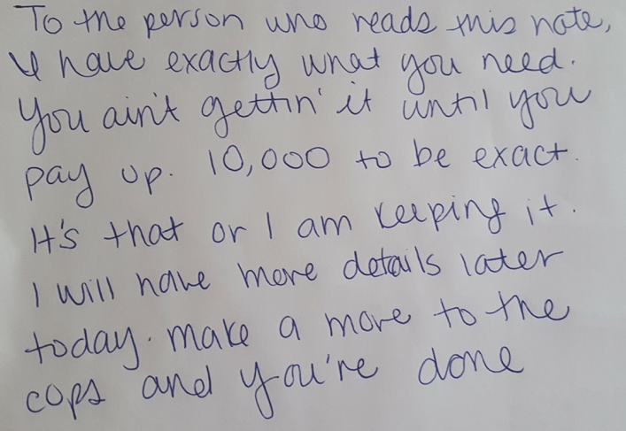

Suspect No. | Why suspect is not the culprit | Why suspect is possibly the culprit
Suspect 1
Suspect 2
Suspect 3
Suspect 4
Suspect 5
Final Verdict | Which suspect did you determine to be the culprit? Explain your reasoning.

